**Assignment no. 5**

**Akshat Shah**

**B22-108**

Importing libraries

> library(ggplot2)

> library(dplyr)

> library(tidyverse)

> library(reshape)

> library(DataExplorer)

> library(openintro)

> library(choroplethr)

Importing data set

> df.raw1<-read.csv(file = 'C:\\Users\\Admin\\Desktop\\mtcars.csv',fileEncoding = "UTF-8-BOM", stringsAsFactors = FALSE)

Head(returns 1st 6 colums)

> head(df.raw1)

model mpg cyl disp hp drat wt qsec vs am gear carb

1 Mazda RX4 21.0 6 160 110 3.90 2.620 16.46 0 1 4 4

2 Mazda RX4 Wag 21.0 6 160 110 3.90 2.875 17.02 0 1 4 4

3 Datsun 710 22.8 4 108 93 3.85 2.320 18.61 1 1 4 1

4 Hornet 4 Drive 21.4 6 258 110 3.08 3.215 19.44 1 0 3 1

5 Hornet Sportabout 18.7 8 360 175 3.15 3.440 17.02 0 0 3 2

6 Valiant 18.1 6 225 105 2.76 3.460 20.22 1 0 3 1

Tail(returns last 5 columns)

> tail(df.raw1)

model mpg cyl disp hp drat wt qsec vs am gear carb

27 Porsche 914-2 26.0 4 120.3 91 4.43 2.140 16.7 0 1 5 2

28 Lotus Europa 30.4 4 95.1 113 3.77 1.513 16.9 1 1 5 2

29 Ford Pantera L 15.8 8 351.0 264 4.22 3.170 14.5 0 1 5 4

30 Ferrari Dino 19.7 6 145.0 175 3.62 2.770 15.5 0 1 5 6

31 Maserati Bora 15.0 8 301.0 335 3.54 3.570 14.6 0 1 5 8

32 Volvo 142E 21.4 4 121.0 109 4.11 2.780 18.6 1 1 4 2

Dim(returns numbers of rows and columns)

> dim(df.raw1)

[1] 32 12

Str (shows data type of each columns)

> str(df.raw1)

'data.frame': 32 obs. of 12 variables:

$ model: chr "Mazda RX4" "Mazda RX4 Wag" "Datsun 710" "Hornet 4 Drive" ...

$ mpg : num 21 21 22.8 21.4 18.7 18.1 14.3 24.4 22.8 19.2 ...

$ cyl : int 6 6 4 6 8 6 8 4 4 6 ...

$ disp : num 160 160 108 258 360 ...

$ hp : int 110 110 93 110 175 105 245 62 95 123 ...

$ drat : num 3.9 3.9 3.85 3.08 3.15 2.76 3.21 3.69 3.92 3.92 ...

$ wt : num 2.62 2.88 2.32 3.21 3.44 ...

$ qsec : num 16.5 17 18.6 19.4 17 ...

$ vs : int 0 0 1 1 0 1 0 1 1 1 ...

$ am : int 1 1 1 0 0 0 0 0 0 0 ...

$ gear : int 4 4 4 3 3 3 3 4 4 4 ...

$ carb : int 4 4 1 1 2 1 4 2 2 4 ...

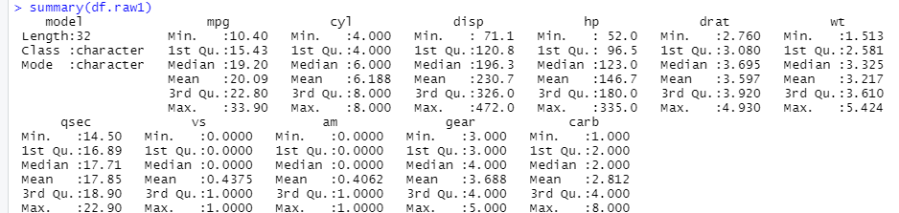Summary(returns summary of data)

Bar Chart

> p = ggplot(mpg, aes(x= class)) + geom_bar()

> p + labs(title = "Number of Cars in each type", x = "Type of car", y = "Number of cars")

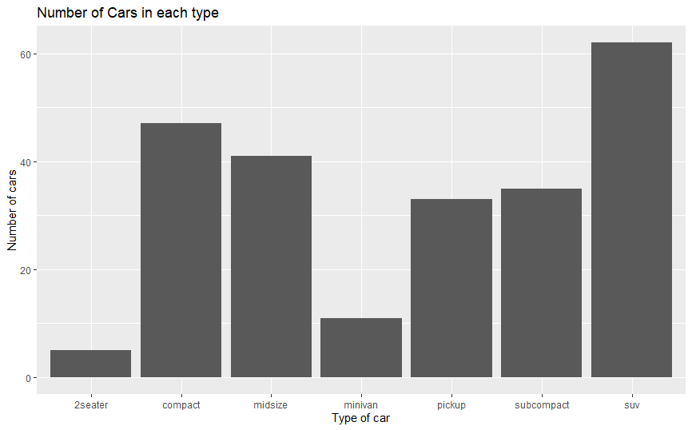

> p <- ggplot(data=mpg, aes(x=class, y=displ, fill=drv))

> p + geom_bar(stat = "identity")

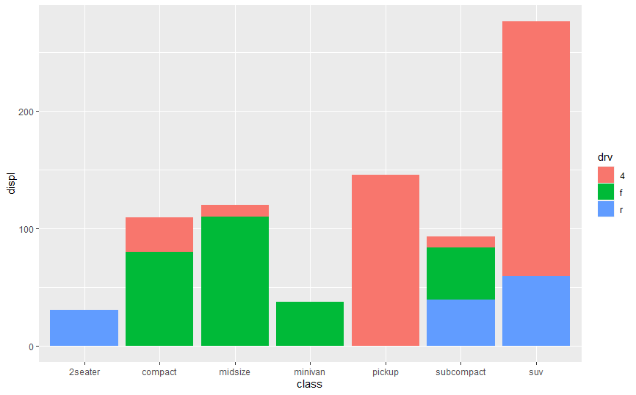

Box plot

> mtcars$cyl = factor(mtcars$cyl)

> ggplot(mtcars, aes(x=cyl, y=disp)) + geom_boxplot()

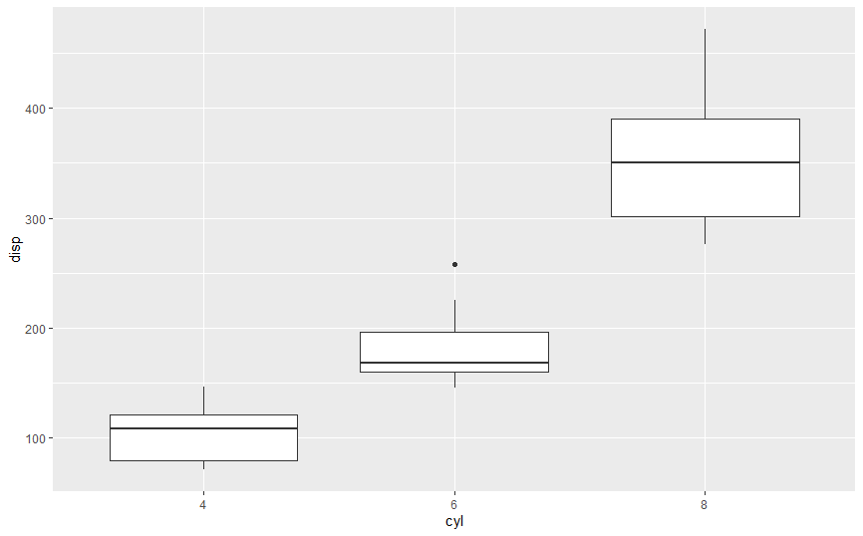

Scatter plot

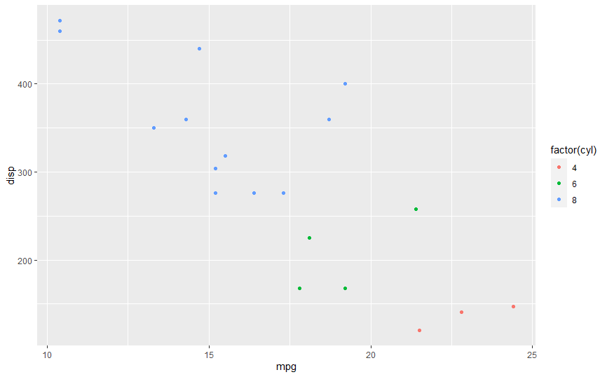> ggplot(data = subset(mtcars,am == 0),aes(x = mpg,y = disp,colour = factor(cyl))) + geom_point()

Histogram

> hist(mtcars$mpg)

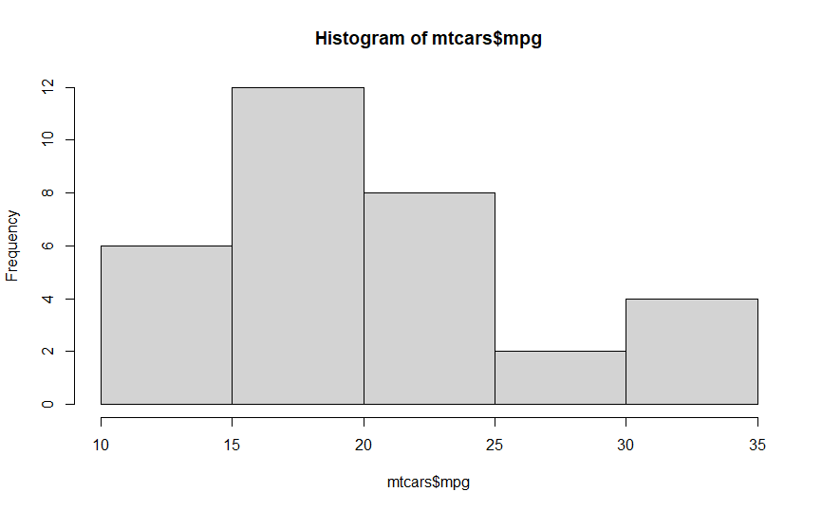

Pie chart

> carburetors <- table(mtcars$carb)

> View(carburetors)

> percent<- round(100*carburetors/sum(carburetors), 1)

> pielabels<- paste(percent, "%", sep="")

> pie(carburetors,col = rainbow(length(carburetors)), labels = percent , main = '% of Carburetors', cex = 0.8)

> legend("topright", c("Carburetor-1","Carburetor-2","Carburetor-3","Carburetor-4","Carburetor-6","Carburetor-8"), cex=0.8, fill= rainbow(length(carburetors)))

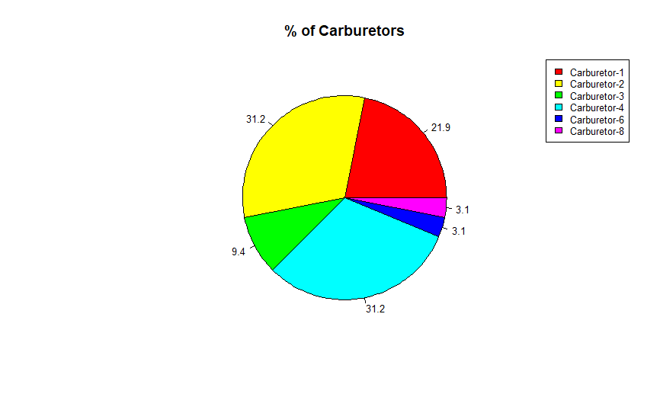

Density Plot

> d <- density(mtcars$mpg)

> plot(d)

